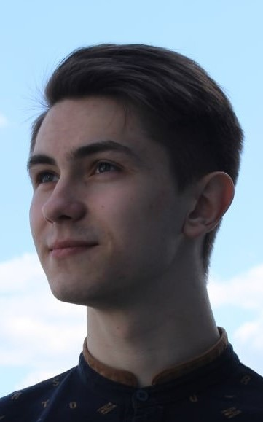

Curriculum vitae

**Date_____09.01.2023______**

|  |  |  |  |  |  |  |
| --- | --- | --- | --- | --- | --- | --- |
| The internship you are interested in | | | | | | |
| **PHP developer** | | | | | | |
| How did you find out about our company?**(Job opening, advertising, article on the internet, friend’s recommendation, etc.)** | | | | | | |
|  | | | | | | |
| Personal details | | | | | | |
| First and Last name | | Vasiliev Artem | | | | |
| Date of birth | | 13.08.2002 | | | | |
| Country of citizenship | | Belarus | | | | |
| Contact information | | | | | | |
| Mobile phone number | | +375(29)5039938 | | | | |
| E-mail | | vasilev6802@mail.ru | | | | |
| Messenger (Telegram, Viber, WhatsApp, etc.) | | Telegram:@rtem_vas | | | | |
| LinkedIn | | linkedin.com/in/artem-vasiliev-723273259 | | | | |
| Projects link (GitHub) | |  | | | | |
| Education | | | | | | |
| **4th year student of Brest State Technical University. Faculty: electronic information systems. Specialty: "automated information processing systems" Skills:  PHP-basic level  Python-basic level  HTML/CSS-basic level  MySQL-basic level** | | | | | | |
| Additional education**(Certificates, courses, seminars, trainings, internships, etc.)** | | | | | | |
|  | | | | | | |
| Foreign languages | | | | | | |
|  | | Level | | | | |
| English | | B1 | | | | |
| German | |  | | | | |
| Others | |  | | | | |
| Professional skills (technologies and programming languages) | | | | | | |
| **Programming languages and technologies** | | Level | | | | |
| Junior | | Middle | Senior | Expert/Architect |
| **Python** | | + | |  |  |  |
| **PHP** | | + | |  |  |  |
|  | |  | |  |  |  |
|  | |  | |  |  |  |
|  | |  | |  |  |  |
|  | |  | |  |  |  |
|  | |  | |  |  |  |
| Professional experience | | | | | | |
| NO | | | | | | |
| **Period** | Company | Job title | Job description | | | |
|  |  |  |  | | | |
|  |  |  |  | | | |
|  |  |  |  | | | |
|  |  |  |  | | | |
| Additional information**(Hobbies, interests, personal qualities, etc.)** | | | | | | |
| **My hobbies: regular trips to the gym, reading articles about new technologies, learning something new.** I can say about myself: I am quite responsible, disciplined and I learn quickly  I can find a common language with everyone. I am not afraid to ask questions and I am always ready to offer help. I take any task seriously and bring it to the end. | | | | | | |